

JAVA COLLECTIONS

ASSIGNMENT

AMIT DHAGE sir

Ramavath Santhosh | 22MCF1R40 | 2nd Sem 1st year MCA

Q1. Convert ArrayList to String array

Method1 : Using ArrayList class get() method

In this example we have converted the whole list to array in three steps  
  
a. Obtain the ArrayList size using size() method  
b. Fetch each element of the list using get() method  
c. Assigned each element to corresponding array element using assignment = operator  
d. Print String array

import java.util.\*;

public class ConvertArrayListToArray {

public static void main(String args[]) {

// Creating and initializing ArrayList

ArrayList<String> fruits = new ArrayList<>();

fruits.add("Apple");

fruits.add("Banana");

fruits.add("Mango");

fruits.add("Pear");

// ArrayList to String array conversion

String[] str = new String[fruits.size()];

for(int i=0; i < fruits.size(); i++) {

str[i] = fruits.get(i);

}

// Print elements using for-each loop

for(String s : str) {

System.out.println(s);

}

}

}

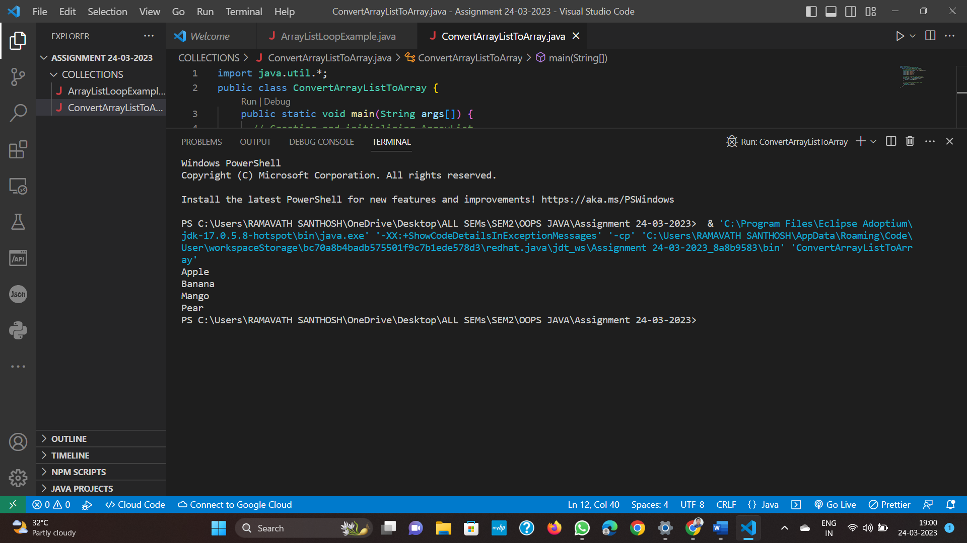

Method 2 : Using ArrayList class toArray() method

In this example we will convert ArrayList to String array using toArray() method.  
  
a. Using toArray() method convert ArrayList to Object array.  
b. Iterate each element and convert them to the desired type using typecasting. Here we are converting to String type and added to the String array.  
c. Last step is to print the String array.

import java.util.\*;

public class ConvertArrayListToArray2 {

public static void main(String args[]) {

// Instantiating and initializing ArrayList

ArrayList<String> cities = new ArrayList<>();

cities.add("Boston");

cities.add("Dallas");

cities.add("San jose");

cities.add("Chicago");

// ArrayList to String array conversion using toArray()

String citinames[]=cities.toArray(new String[cities.size()]);

// Printing elements using for-each loop

for(String str : citinames) {

System.out.println(str);

}

}

}

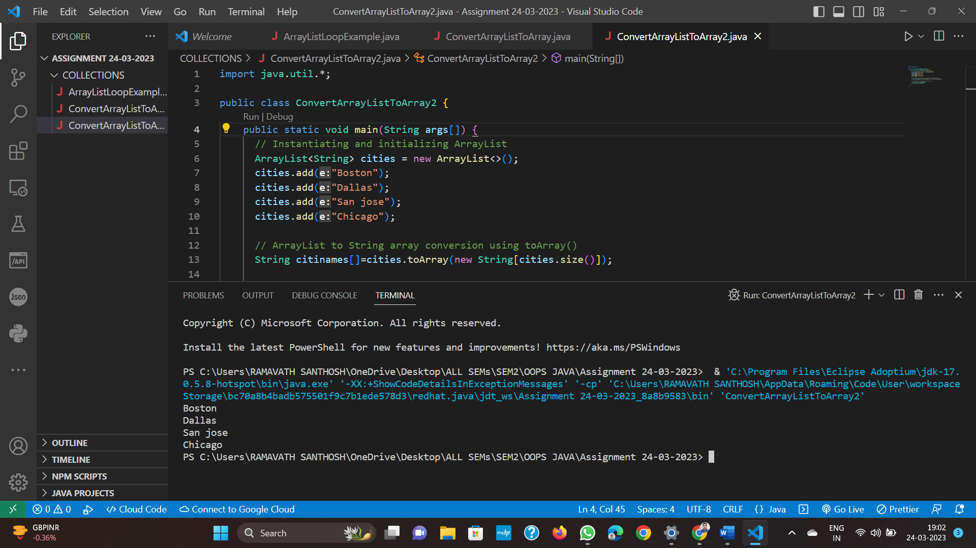

Method3 : Using Arrays class copyOf() method

In this example, we will convert the ArrayList to String array using Arrays class copyOf() method.  
  
a. First, just like above example convert the ArrayList to Object array using toArray() method.  
b. Use Arrays.copyOf() method to convert Object array to String array.  
c. Show the String array.

import java.util.\*;

public class ConvertArrayListToArray3 {

public static void main(String args[]) {

// Declaring and initializing ArrayList in one step

ArrayList<String> browsers = new ArrayList<>();

browsers.add("Google Chrome");

browsers.add("Mozilla Firefox");

browsers.add("Edge");

browsers.add("Opera");

//Converting ArrayList to String array using copyOf()

String[] browsernames = Arrays.copyOf(browsers.toArray(), browsers.size(), String[].class);

// Displaying elements using for-each loop

for(String str : browsernames) {

System.out.println(str);

}

}

}

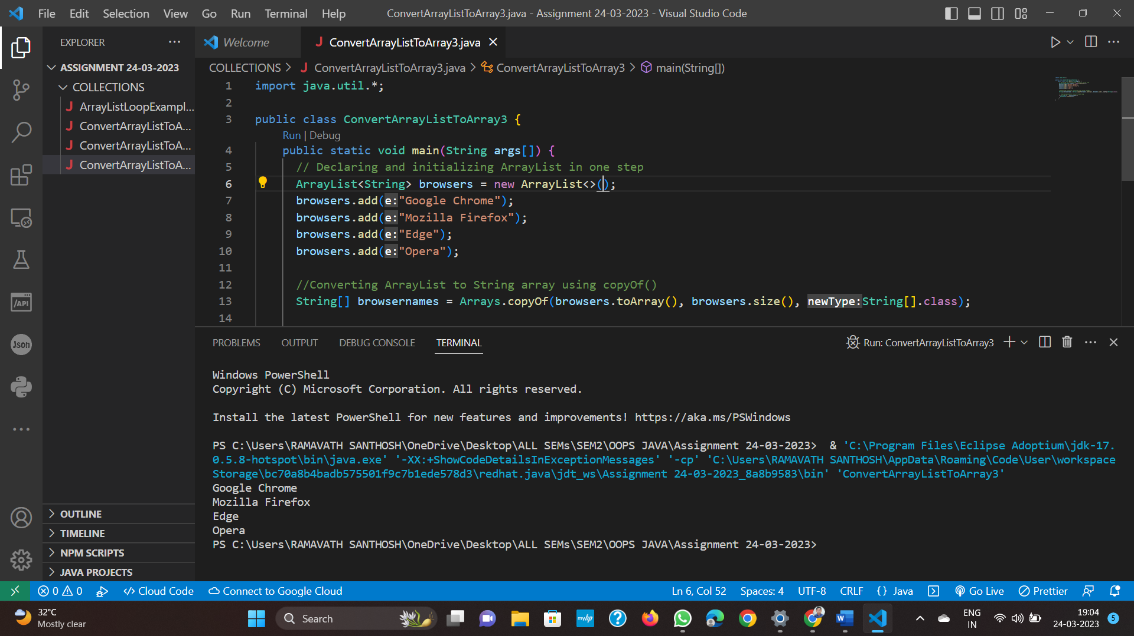

Q2. Write a program to traverse (or iterate) ArrayList?   
  
Traverse ArrayList using for loop, while loop, advance for loop and iterator. This question tests knowledge of add() method of ArrayList and looping concept. Below example traverses ArrayList using advance for loop:

import java.util.\*;

public class ArrayListLoopExample {

public static void main(String args[]) {

// initialize ArrayList

ArrayList<Integer> al = new ArrayList<Integer>();

// add elements to ArrayList object

al.add(3);

al.add(17);

al.add(6);

al.add(9);

al.add(7);

System.out.println("Using Advanced For Loop");

// printing ArrayList

for (Integer num : al) {

System.out.println(num);

}

}

}

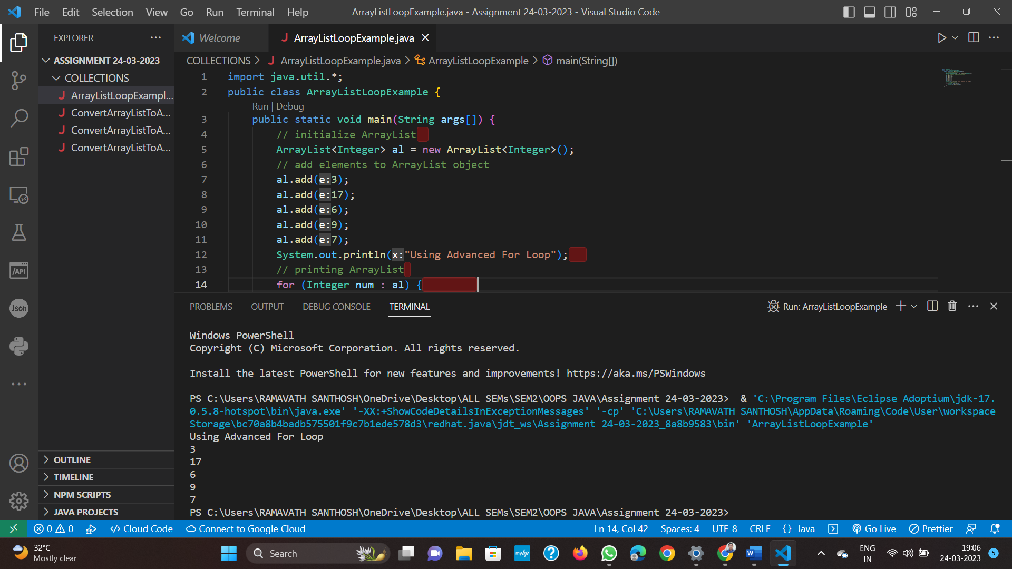

Q3. Program for How to Iterate HashSet Using Iterator

import java.util.\*;

public class HashSetIteratorExample {

public static void main(String args[]) {

// Declaring a HashSet

HashSet<String> hashset = new HashSet<String>();

// Add elements to HashSet

hashset.add("Pear");

hashset.add("Apple");

hashset.add("Orange");

hashset.add("Papaya");

hashset.add("Banana");

// Get iterator

Iterator<String> it = hashset.iterator();

// Show HashSet elements

System.out.println("HashSet contains: ");

while(it.hasNext()) {

System.out.println(it.next());

}

}

}

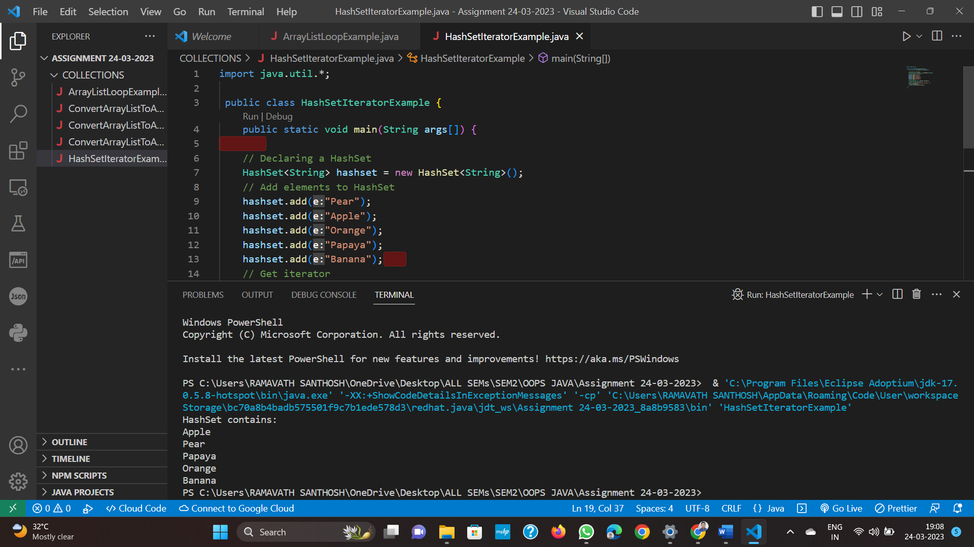

Q4. Program for How to Iterate HashSet using for each loop

import java.util.\*;

public class HashSetIteratorExample {

public static void main(String args[]) {

// Declaring a HashSet

HashSet<String> hashset = new HashSet<String>();

// Add elements to HashSet

hashset.add("Pear");

hashset.add("Apple");

hashset.add("Orange");

hashset.add("Papaya");

hashset.add("Banana");

System.out.println("HashSet contains :");

// Using for each loop

for(String str : hashset){

System.out.println(str);

}

}

}

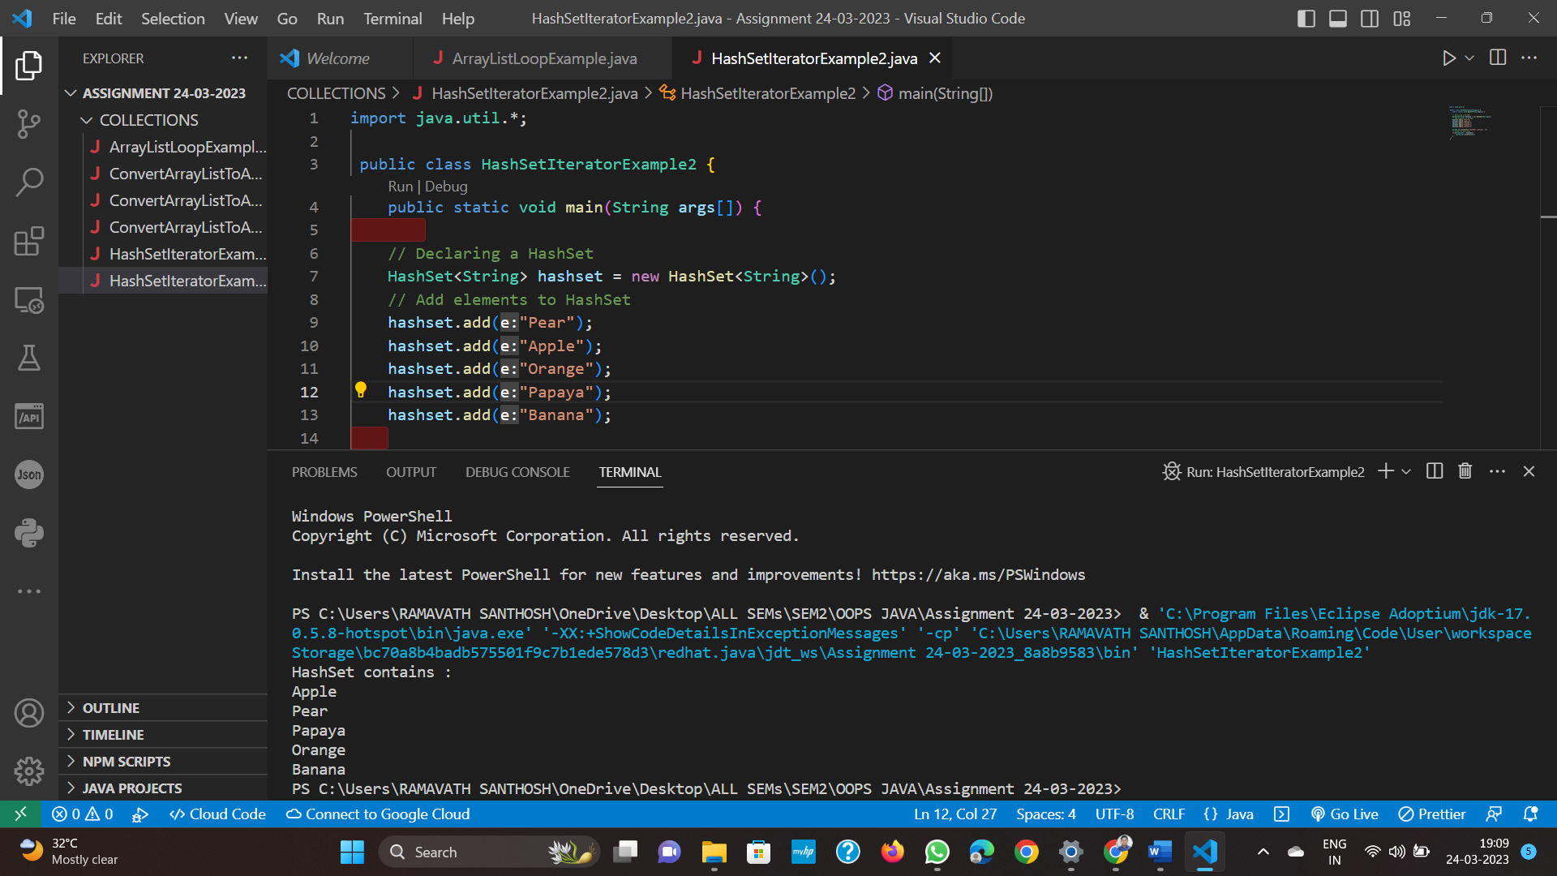

 Q5. Given an element write a program to check if element(value) exists in ArrayList?

import java.util.\*;

public class ArrayListContainsExample {

public static void main(String args[]) {

// initialize ArrayList

ArrayList<Integer> al = new ArrayList<Integer>();

// add elements to ArrayList object

al.add(3);

al.add(17);

al.add(6);

al.add(9);

al.add(7);

// check if ArrayList contains element

if (al.contains(7)) {

System.out.println("7 was found in the list");

} else {

System.out.println("7 was not found in the list");

}

}

}

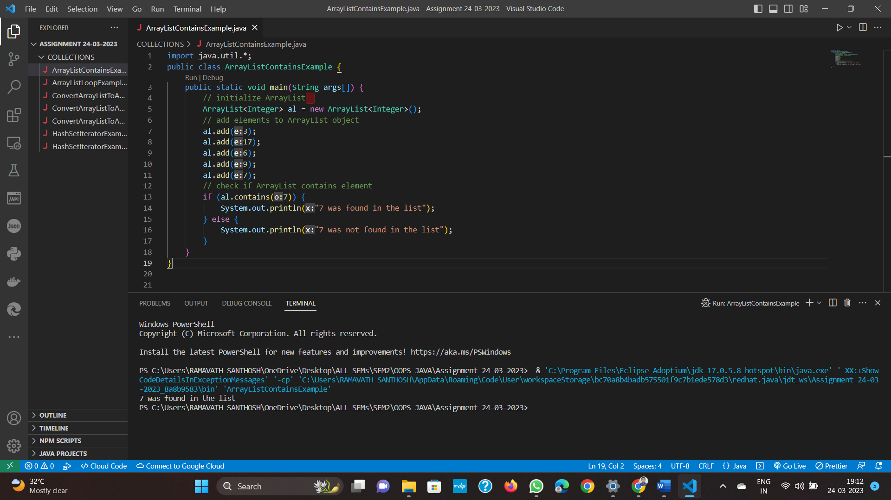  
  
Q6 Given an element write a program to check if element exists in HashSet?

import java.util.\*;

public class HashSetContainsExample {

public static void main(String args[]) {

// initialize HashSet

HashSet<Integer> hs = new HashSet<Integer>();

// add elements to HashSet object

hs.add(3);

hs.add(17);

hs.add(6);

hs.add(9);

hs.add(7);

// check if HashSet contains element

if (hs.contains(7)) {

System.out.println("7 was found in the list");

} else {

System.out.println("7 was not found in the list");

}

}

}



Q7. Convert an Array to ArrayList in Java

Method 1 : Using Arrays.asList() method

In this example, we are converting an Array to ArrayList using Arrays class asList() method. The syntax is given below:  
  
Syntax :  
 ArrayList<String> list = new ArrayList<>(Arrays.asList(arrayname));

import java.util.\*;

public class ConvertArrayToArrayList {

public static void main(String args[]) {

// Declaring and initializing Array

String[] cities={"Boston", "Dallas", "New York", "Chicago"};

//Converting Array to ArrayList using Arrays.asList()

ArrayList<String> list= new ArrayList<>(Arrays.asList(cities));

// Add more elements to the converted list

list.add("San Francisco");

list.add("San jose");

// Print arraylist elements using for-each loop

for(String s : list) {

System.out.println(s);

}

}

}

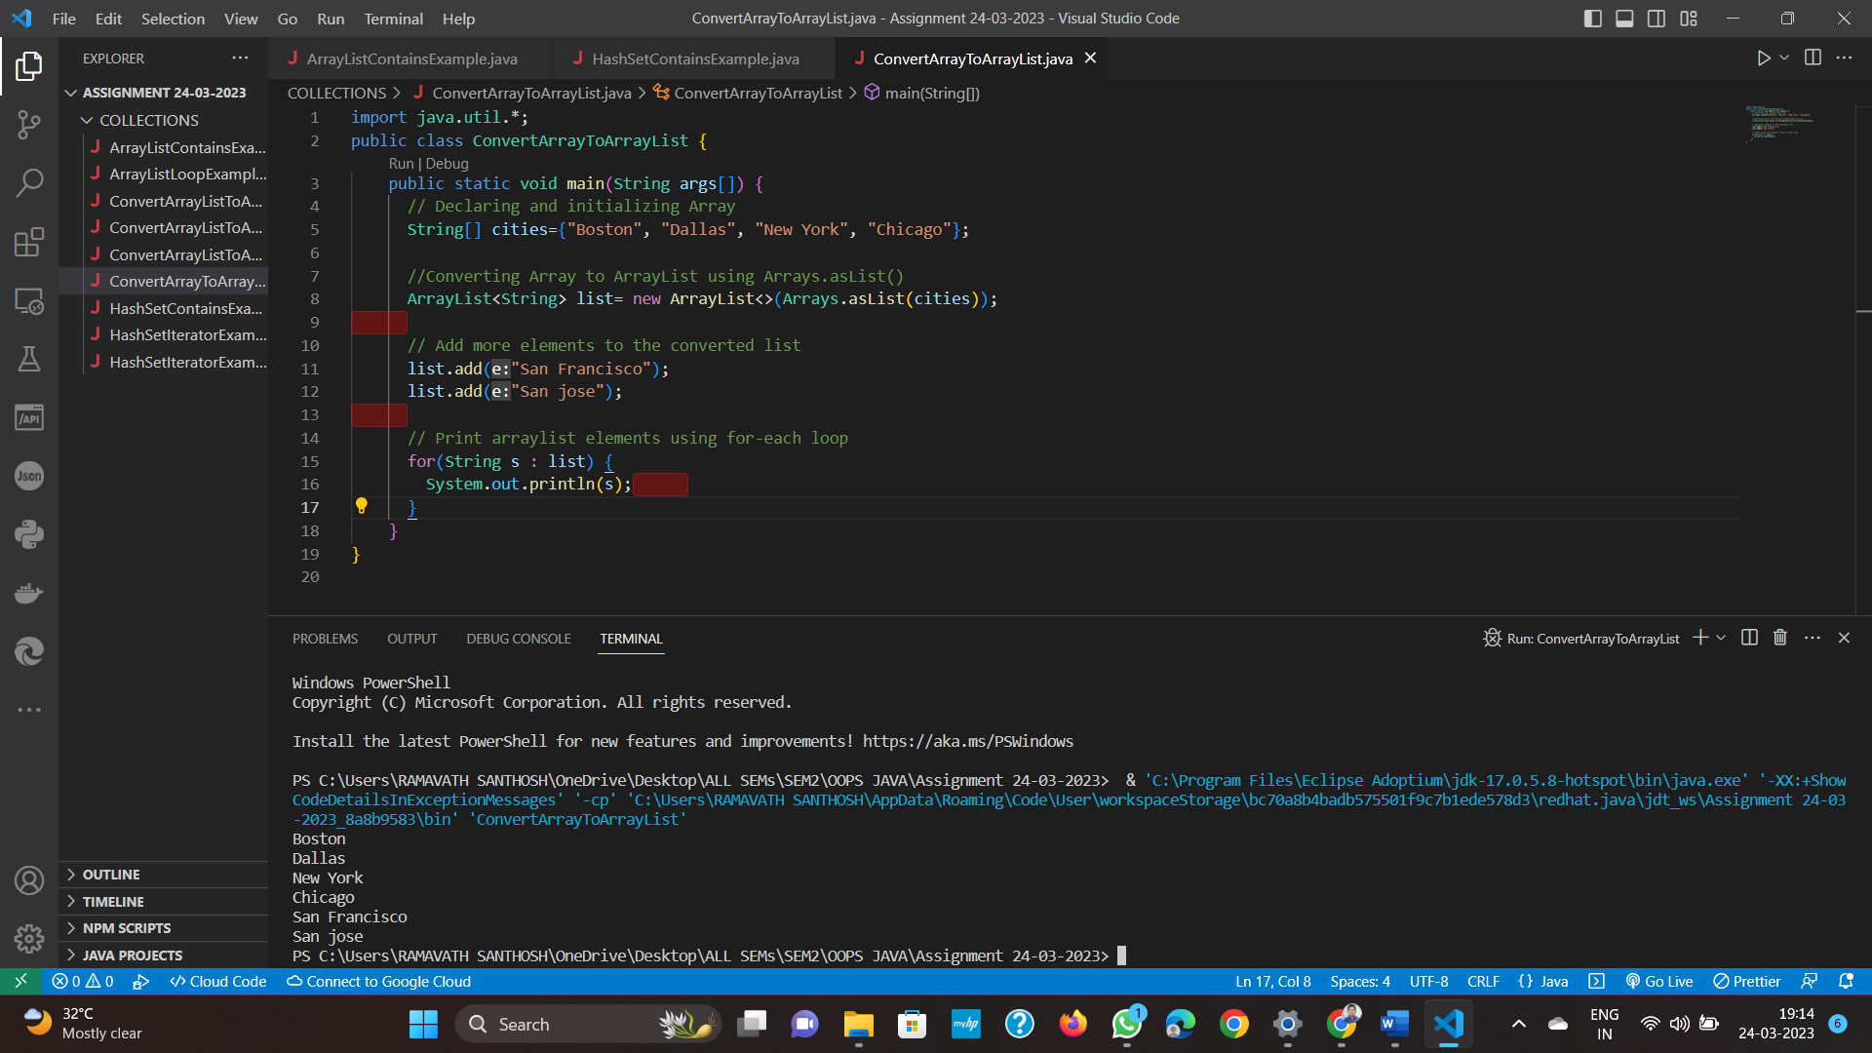

Method 2 : Using Collections.addAll() method

This method does the same as Arrays.asList() method however it is much faster hence performance wise this is the best way to convert Array to ArrayList. The syntax for the addAll() method is given below:  
  
Syntax:  
Collections.addAll(arraylist, array);

import java.util.\*;

public class ConvertArrayToArrayList2 {

public static void main(String args[]) {

// Creating and initializing Array

String[] strArray = {"AAA", "BBB", "CCC", "DDD"};

// Declaring ArrayList

ArrayList<String> al = new ArrayList<>();

//Converting Array to ArrayList using addAll() method

Collections.addAll(al, strArray);

// Add more elements to the converted list

al.add("YYY");

al.add("ZZZ");

// Displaying arraylist elements using for-each loop

for(String s : al) {

System.out.println(s);

}

}

}

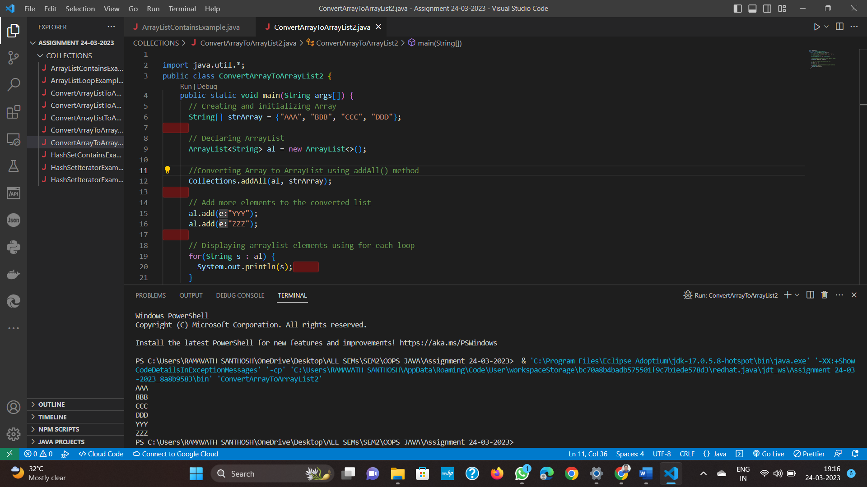

Method 3 : Using add() method

If we don't want to use java built-in methods then we can use add() method to convert an array to ArrayList. This is a manual way of adding all the array elements to the ArrayList as shown below:

import java.util.\*;

public class ConvertArrayToArrayList3 {

public static void main(String args[]) {

// Declaring and instantiating ArrayList in one step

ArrayList<String> al = new ArrayList();

// Given initialized array

String[] strArray = {"Cocacola", "Pepsi", "Fanta", "Dr Pepper"};

//Converting Array to ArrayList manually

for (int i=0; i < strArray.length ; i++) {

// Adding every element of array to the ArrayList

al.add(strArray[i]);

}

// Showing arraylist elements using for-each loop

for(String str1 : al) {

System.out.println(str1);

}

}

}

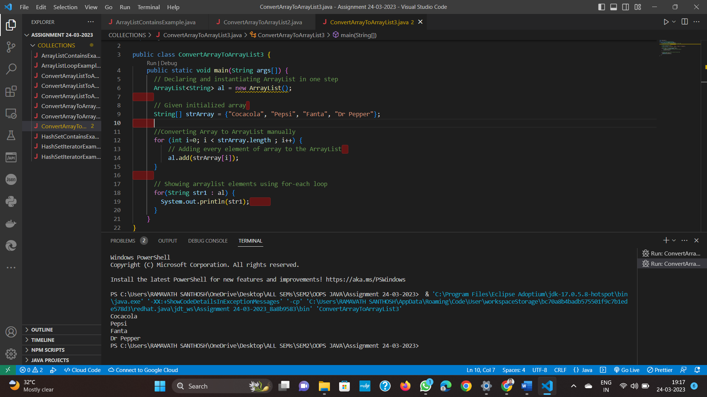

Q8. ArrayList size() example in Java

When you create an Object of an ArrayList, it is created as empty ArrayList  and it's size() will be zero.If you add elements one by one then size grows one by one.

1. Java Program to find Length/Size of Integer ArrayList

import java.util.\*;

import java.io.\*;

/\* Write a program to determine the size/length of the ArrayList\*/

public class ArrayListSize

{

public static void main (String[] args)

{

  // Create an Integer ArrayList Object

 ArrayList<Integer> arrlist=new ArrayList<Integer>();

// Print initial size of ArrayList

 System.out.println("Size before adding elements: "+arrlist.size());

  // Adding elements to ArrayList Object

 arrlist.add(11);

arrlist.add(3);

arrlist.add(5);

arrlist.add(4);

arrlist.add(9);

/\* Print size of ArrayList

after adding elements \*/

System.out.println("Size after adding elements: "+arrlist.size());

// Removing elements from ArrayList

 arrlist.remove(1);

arrlist.remove(2);

/\* Print size of ArrayList

  after removing elements \*/

System.out.println("Size after removing elements: "+arrlist.size());

  // Print ArrayList

 System.out.println("Resulting ArrayList: ");

for(int num: arrlist){

System.out.println(num);

}

}

}

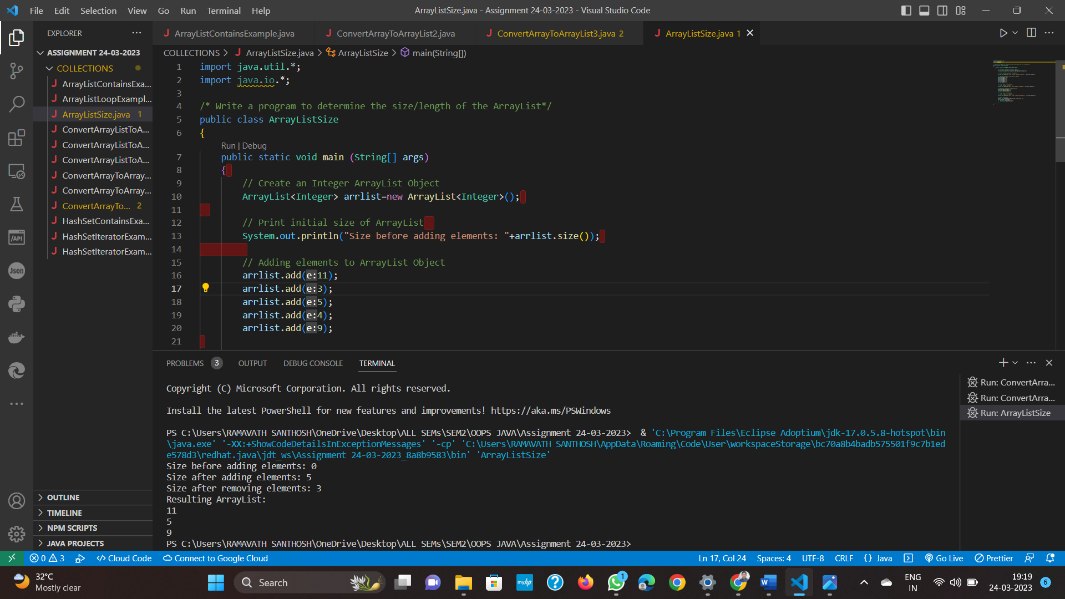

Q9. Java Program to find Length/Size of String ArrayList

import java.util.\*;

import java.io.\*;

/\* Program to find size of ArrayList in Java \*/

public class ArrayListSize

{

public static void main (String[] args)

{

System.out.println("Java Program to find the size of ArrayList");

// Create an String ArrayList Object

ArrayList<String> listOfCities = new ArrayList<>();

int size = listOfCities.size();

// Print initial size of ArrayList

System.out.println("size of ArrayList after creation: " + size);

// Adding elements to ArrayList Object

listOfCities.add("California");

listOfCities.add("Boston");

listOfCities.add("New York");

size = listOfCities.size();

/\* Print size of ArrayList

after adding elements \*/

System.out.println("size of ArrayList after adding elements: " + size);

// clear() method removes all elements

listOfCities.clear();

size = listOfCities.size();

System.out.println("size of ArrayList after clearing elements: " + size);

}

}

Q10. Write a program to add elements to HashSet?

import java.util.\*;

public class HashSetAddExample {

public static void main(String args[]) {

// initialize HashSet

HashSet<Integer> hs = new HashSet<Integer>();

// add elements to HashSet object

hs.add(3);

hs.add(17);

hs.add(6);

hs.add(9);

hs.add(7);

System.out.println("Using Advanced For Loop");

// printing HashSet

for (Integer num : hs) {

System.out.println(num);

}

}

}

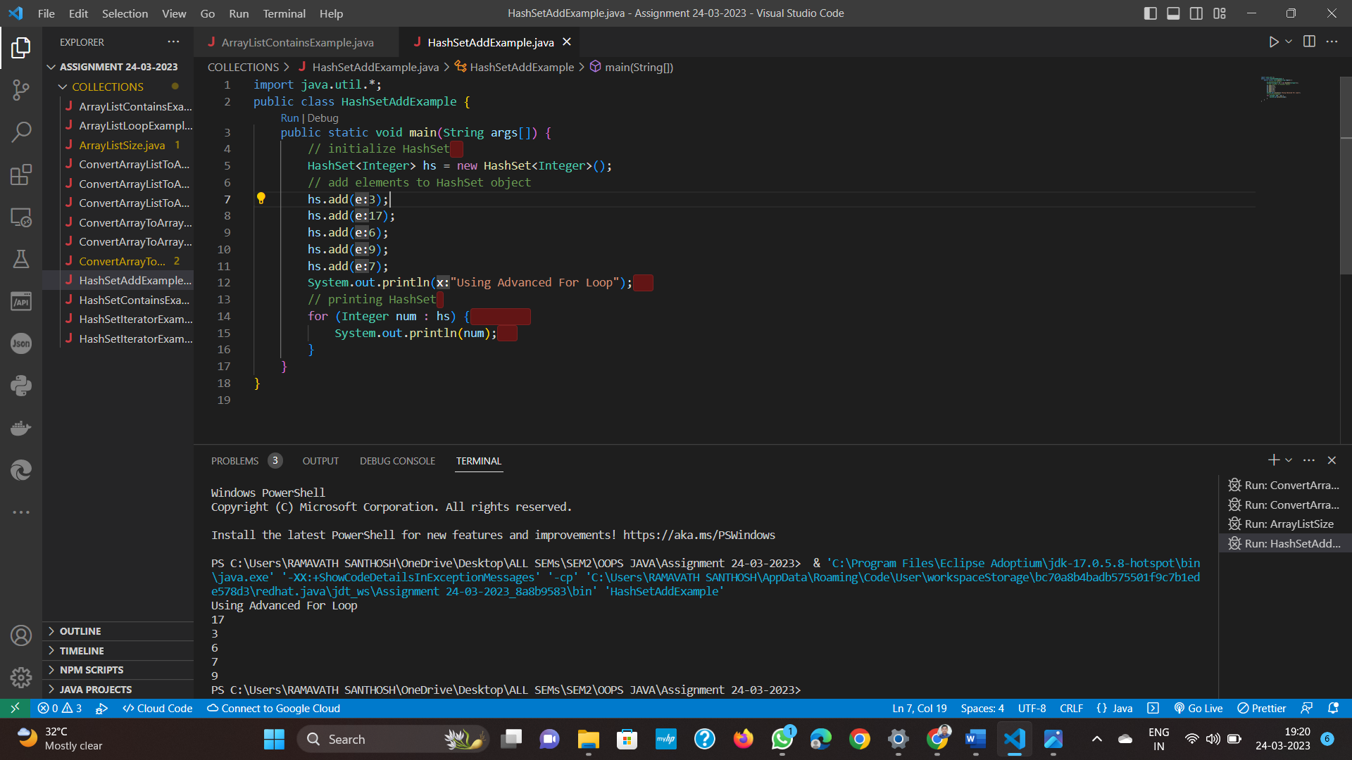

Q11. Get Size of HashMap Example

HashMap with Integer keys and String values

import java.util.\*;

public class HashMapSizeExample {

public static void main(String args[]) {

// Creating HashMap object with Integer keys and String values

HashMap<Integer,String> map = new HashMap<>();

// Adding elements to the HashMap object

map.put(1, "CocoCola");

map.put(2, "Pepsi");

map.put(3, "Thums Up");

map.put(4, "Fanta");

// Calculating the size of the HashMap using size() method

System.out.println(" Size of the given HashMap is: "+ map.size());

}

}

Q12. Program for How to Check if a HashMap is Empty or Not

import java.util.HashMap;

public class HashMapEmptyExample {

public static void main(String args[]) {

// Creating HashMap object with Integer keys and String values

HashMap<Integer, String> map = new HashMap<>();

// Checking whether HashMap is empty or not

System.out.println("Checking Is HashMap empty?: " + map.isEmpty());

// Adding elements to the HashMap object

map.put(100, "Jack");

map.put(200, "John");

map.put(300, "Smith");

// Checking again whether HashMap is empty or not

System.out.println("Checking Is HashMap empty?: "+ map.isEmpty());

}

}

Output:  
Checking Is HashMap empty?: true  
Checking Is HashMap empty?: false

Using size() method

I have already explained the size() method . We can easily check if HashMap is empty or not by using size() method. If size() method returns 0 then the HashMap is empty otherwise not.

import java.util.\*;

public class HashMapEmptyExample2 {

public static void main(String args[]) {

// Creating HashMap object with String keys and String values

HashMap<String, String> map = new HashMap<>();

// Checking whether HashMap is empty or not using size() method

System.out.println("Checking Is HashMap empty using size() method?: " + (map.size()==0));

// Putting elements to the HashMap object

map.put("100", "Java");

map.put("1000", "Python");

map.put("10000", "Javascript");

// Checking again whether HashMap is empty or not using size() method

System.out.println("Checking Is HashMap empty using size() method?: "+ (map.size()==0));

}

}

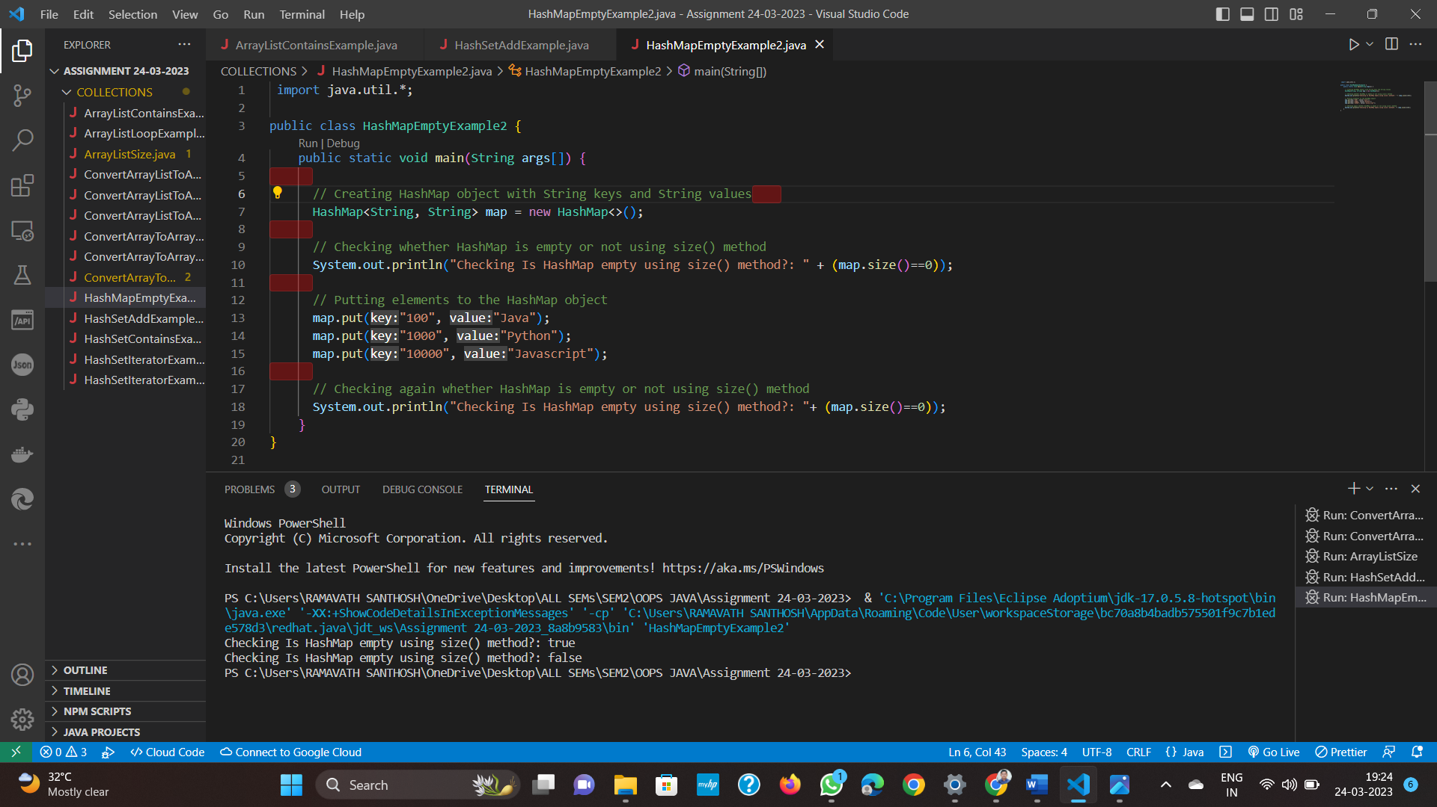

Q13. Program for Sorting HashMap by Keys

import java.util.\*;

public class HashMapSortByKeyExample {

public static void main(String args[]) {

// Creating a HashMap of int keys and String values

HashMap<Integer, String> hashmap = new HashMap<Integer, String>();

// Adding Key and Value pairs to HashMap

hashmap.put(22,"A");

hashmap.put(55,"B");

hashmap.put(33,"Z");

hashmap.put(44,"M");

hashmap.put(99,"I");

hashmap.put(88,"X");

System.out.println("Before Sorting:");

Set set = hashmap.entrySet();

Iterator iterator = set.iterator();

while(iterator.hasNext()) {

Map.Entry pair = (Map.Entry)iterator.next();

System.out.print(pair.getKey() + ": ");

System.out.println(pair.getValue());

}

Map<Integer, String> map = new TreeMap<Integer, String>(hashmap); System.out.println("After Sorting:");

Set set2 = map.entrySet();

Iterator iterator2 = set2.iterator();

while(iterator2.hasNext()) {

Map.Entry pair = (Map.Entry)iterator2.next();

System.out.print(pair.getKey() + ": ");

System.out.println(pair.getValue());

}

}

}

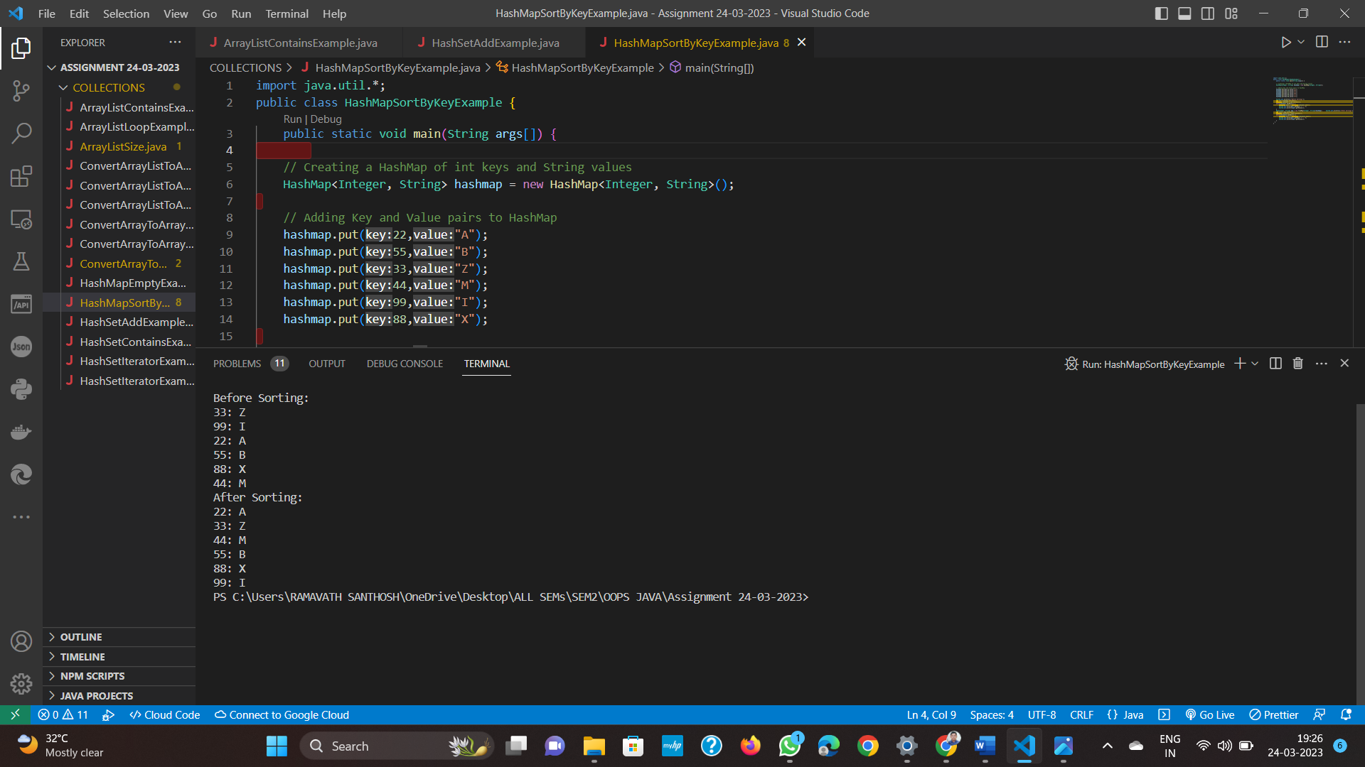

HashMap Sorting by Values   
  
In this example we are sorting HashMap by values using Comparator.  
  
Program for Sorting HashMap by Values

import java.util.\*;

public class HashMapSortByValueExample {

public static void main(String args[]) {

// Creating a HashMap of int keys and String values

HashMap<Integer, String> hashmap = new HashMap<Integer, String>();

// Adding Key and Value pairs to HashMap

hashmap.put(22,"A");

hashmap.put(55,"B");

hashmap.put(33,"Z");

hashmap.put(44,"M");

hashmap.put(99,"I");

hashmap.put(88,"X");

System.out.println("Before Sorting:");

Set set = hashmap.entrySet();

Iterator iterator = set.iterator();

while(iterator.hasNext()) {

Map.Entry pair = (Map.Entry)iterator.next();

System.out.print(pair.getKey() + ": ");

System.out.println(pair.getValue());

}

Map<Integer, String> map = sortByValues(hashmap);

System.out.println("After Sorting:");

Set set2 = map.entrySet();

Iterator iterator2 = set2.iterator();

while(iterator2.hasNext()) {

Map.Entry pair = (Map.Entry)iterator2.next();

System.out.print(pair.getKey() + ": ");

System.out.println(pair.getValue());

}

}

private static HashMap sortByValues(HashMap map) {

List list = new LinkedList(map.entrySet());

// Defined Custom Comparator here

Collections.sort(list, new Comparator() {

public int compare(Object o1, Object o2) {

return ((Comparable) ((Map.Entry) (o1)).getValue())

.compareTo(((Map.Entry) (o2)).getValue());

}

});

// Here I am copying the sorted list in HashMap

// using LinkedHashMap to preserve the insertion order

HashMap sortedHashMap = new LinkedHashMap();

for (Iterator it = list.iterator(); it.hasNext();) {

Map.Entry entry = (Map.Entry) it.next();

sortedHashMap.put(entry.getKey(), entry.getValue());

}

return sortedHashMap;

}

}

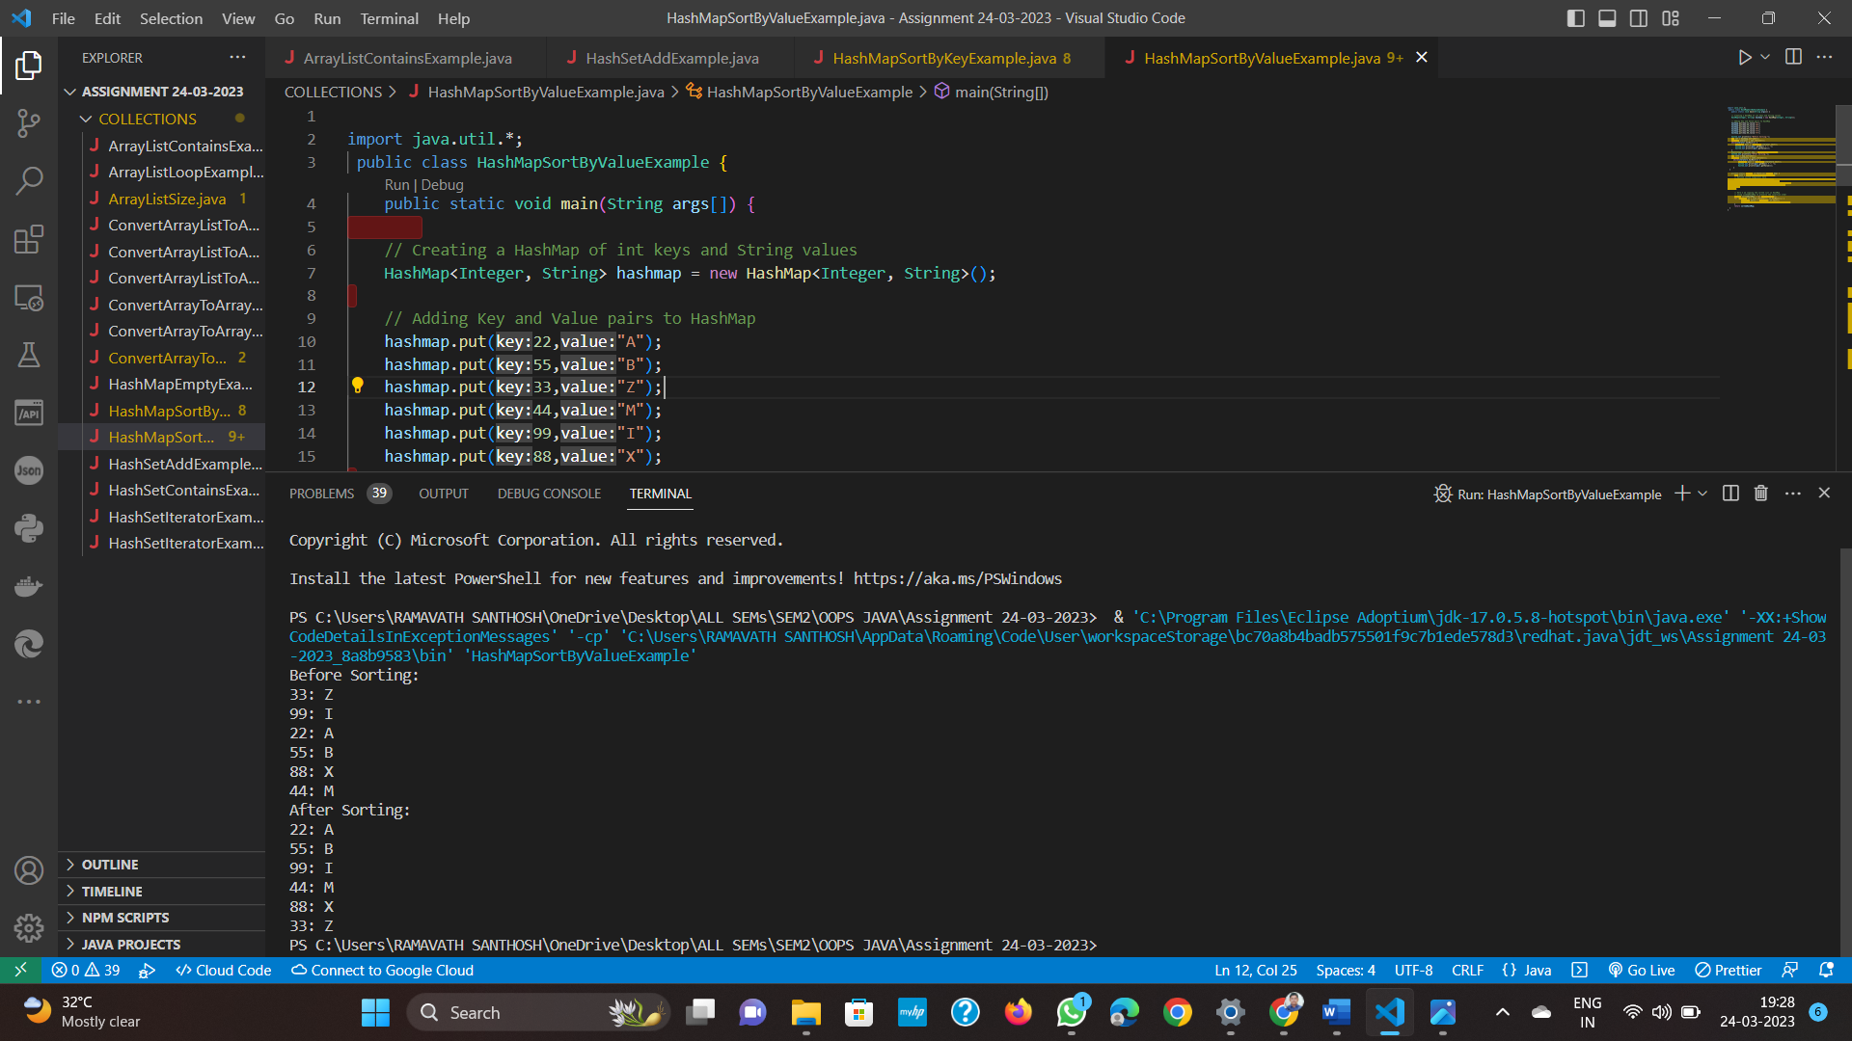

Q14 Why do we need Comparable and Comparator?  
  
In the below example we have a Student class which has properties like roll no.,Student name and Student age.

public class Student {

private String studentname;

private int rollno;

private int studentage;

public Student(int rollno, String studentname, int studentage) {

this.rollno = rollno;

this.studentname = studentname;

this.studentage = studentage;

}

public String getStudentname() {

return studentname;

}

public void setStudentname(String studentname) {

this.studentname = studentname;

}

public int getRollno() {

return rollno;

}

public void setRollno(int rollno) {

this.rollno = rollno;

}

public int getStudentage() {

return studentage;

}

public void setStudentage(int studentage) {

this.studentage = studentage;

}

}

We will add Students to the ArrayList object.

import java.util.\*;

public class ArrayListSort {

public static void main(String args[]) {

ArrayList<Student> arraylist = new ArrayList<Student>();

arraylist.add(new Student(111, "John", 23));

arraylist.add(new Student(222, "Messi", 29));

arraylist.add(new Student(333, "Ronaldo", 31));

Collections.sort(arraylist);

for(Student str: arraylist){

System.out.println(str);

}

}

}

We tried to call the Collections.sort() method on List of Objects and got the following error message.

Exception in thread “main” java.lang.Error: Unresolved compilation problem:  
Bound mismatch: The generic method sort(List) of type Collections is not applicable for the arguments (ArrayList). The inferred type Student is not a valid substitute for the bounded parameter > at ArrayListSort.main(ArrayListSort.java:15)

Reason : I just called the sort method on an ArrayList of Objects which doesn't work until unless we use interfaces like Comparable and Comparator. Now we will use Comparable and Comparator to get the sorting done in our way.  
  
Q15 Sorting of ArrayList(Object) Using Comparable

Suppose we need to sort the ArrayList object based on student Age property.To achieve this we will first implement Comparable interface and then override the compareTo() method.

public class Student implements Comparable {

private String studentname;

private int rollno;

private int studentage;

public Student(int rollno, String studentname, int studentage) {

this.rollno = rollno;

this.studentname = studentname;

this.studentage = studentage;

}

...

//getter and setter methods same as the above example

...

@Override

public int compareTo(Student comparestu) {

int compareage=((Student)comparestu).getStudentage();

/\* For Ascending order\*/

return this.studentage-compareage;

/\* For Descending order do like this \*/

//return compareage-this.studentage;

}

@Override

public String toString() {

return "[ rollno=" + rollno + ", name=" + studentname + ", age=" + studentage + "]";

}

}

Now we can call Collections.sort() on ArrayList

import java.util.\*;

public class ArrayListSort {

public static void main(String args[]) {

ArrayList<Student> arraylist = new ArrayList<Student>();

arraylist.add(new Student(222, "Messi", 29));

arraylist.add(new Student(333, "Ronaldo", 31));

arraylist.add(new Student(111, "john", 23));

Collections.sort(arraylist);

for(Student str: arraylist){

System.out.println(str);

}

}

}

Why do we need Comparator when we Already have Comparable  
  
If you want to have more than one way of sorting your class, you must implement Comparator.   
  
Q16 Sorting ArrayList(Object)  Multiple Properties Using Comparator  
  
To implement Comparator we need to override compare method for sorting.

import java.util.Comparator;

public class Student {

private String studentname;

private int rollno;

private int studentage;

public Student(int rollno, String studentname, int studentage) {

this.rollno = rollno;

this.studentname = studentname;

this.studentage = studentage;

}

...

//Getter and setter methods same as the above examples

...

/\*Comparator for sorting the list by Student Name\*/

public static Comparator<Student> StuNameComparator = new Comparator<Student>() {

public int compare(Student s1, Student s2) {

String StudentName1 = s1.getStudentname().toUpperCase();

String StudentName2 = s2.getStudentname().toUpperCase();

//ascending order

return StudentName1.compareTo(StudentName2);

//descending order

//return StudentName2.compareTo(StudentName1);

}};

/\*Comparator for sorting the list by roll no\*/

public static Comparator<Student> StuRollno = new Comparator<Student>() {

public int compare(Student s1, Student s2) {

int rollno1 = s1.getRollno();

int rollno2 = s2.getRollno();

/\*For ascending order\*/

return rollno1-rollno2;

/\*For descending order\*/

//rollno2-rollno1;

}};

@Override

public String toString() {

return "[ rollno=" + rollno + ", name=" + studentname + ", age=" + studentage + "]";

}

Q17 ArrayList Class

import java.util.\*;

public class ArrayListSort {

public static void main(String args[]){

ArrayList<Student> arraylist = new ArrayList<Student>();

arraylist.add(new Student(111, "John", 30));

arraylist.add(new Student(333, "Ronaldo", 31));

arraylist.add(new Student(222, "Messi", 29));

/\*Sorting based on Student Name\*/

System.out.println("Student Name Sorting:");

Collections.sort(arraylist, Student.StuNameComparator);

for(Student str: arraylist){

System.out.println(str);

}

/\* Sorting on Rollno property\*/

System.out.println("RollNum Sorting:");

Collections.sort(arraylist, Student.StuRollno);

for(Student str: arraylist){

System.out.println(str);

}

}

}